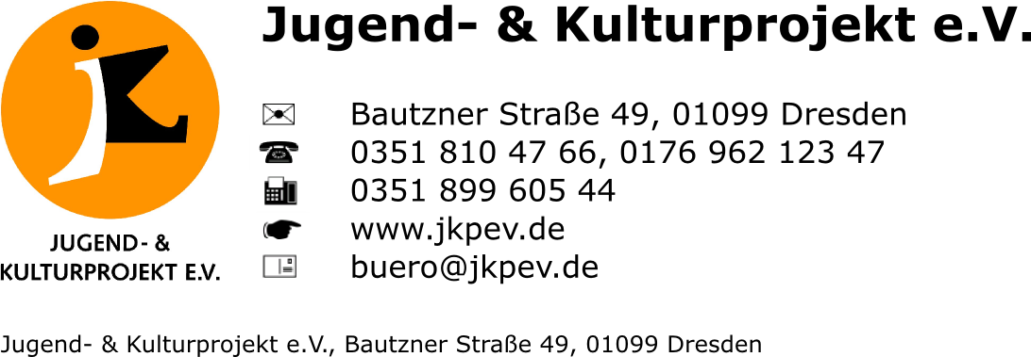

UrbanArtVentures II

Training Course
Volos, Greece

12 – 21 September 2017

Photo

APPLICANT PERSONAL DATA

Before filling out the registration form, please read carefully the info pack!

Sending organisation:
First Name:
Family name:
Date of Birth:
Gender: | Female |  |  | Male
Tel. number:
Mob. number:
Fax:
E-mail:
Facebook:
Address: | Street name
Address: | Postcode
Address: | Region
Address: | City
Address: | Country
Emergency contact: | Name
Emergency contact: | Mobile
Dietary needs:

Level of English language (none, fair, good, very good, fluent, native speaker)

What is your profession? Are you a street artist or a youth worker? How much experience have you got in one or both of these fields? Please elaborate.

Have you got experience as an urban art educator or facilitator of street art projects? If yes, please elaborate.

Why would you like to participate in UrbanArtExpress II project? How can you contribute to it?

Will you be able to share with us best practices of your country using street art in social and youth projects? Please describe at least one similar project in your country.

Have you participated in any Erasmus+ projects (training courses, youth exchanges, seminars)? If yes, please describe 2 projects you have been involved in and your role in these projects.

Please describe your concept about a mural artwork you would to work on with other street artists and youth workers related to the main topic of this project.

Do you need any specific materials/toos/equipment? Please elaborate.

Will you join the excursion to Pelion? There is a participation fee of 30 €

Please fill out the registration form and send it to together with your portfolio to myrto.pertsinidi@jkpev.de

